
Policy Book

August 2, 2026

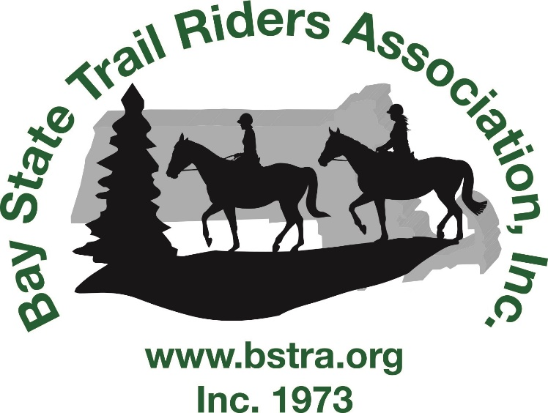

Contents
POLICY 2
RIDES 2
N.E.H.T Affiliated Rides 2
Hunter Pace Events 2
TRAIL/EVENT ETIQUETTE 3
VOLUNTEERING 3
YEAR END AWARDS 3

POLICY

RIDES

- Unless otherwise noted, all rides start at 10 am and trail workdays at 9 am.
- Unless otherwise noted, rides require advance registration and payment to receive lunch.
- Riders 17 years old and under, ride free (including lunch if pre-registered).
  - Helmets are required for any rider 17 or under and rider must be accompanied by a guardian.
- Rides are rain or shine! In case of questionable weather, call the ride contact before leaving home (or check Facebook). You will NOT be called if the event is cancelled.
  - If a ride is cancelled, payments will be refunded.
  - Prior to the registration deadline, refunds can be made.
  - After the registration deadline, refunds will be at the discretion of the ride contact if due to extenuating circumstances. (ie; horse or rider disabled/hurt, accident, transportation becomes unavailable)
    - NOTE: Refund may be reduced to cover any costs incurred.

- Alcohol and marijuana use is prohibited on State property. Smoking tobacco is prohibited while riding.
- A current negative Coggins within a year of the ride date is required at all BSTRA rides.
- All ride sponsors can receive a pair of ride passes or invitations to lunch (RSVP requested) for the ride they are sponsoring.
- A person can receive ride points for marking a trail if they don’t ride on the day of the ride, but they must have registered and paid for the ride.

N.E.H.T Affiliated Rides

- “Double mileage” pertains only to those rides advertised as such on the BSTRA calendar.
Responsibility for making this designation lies with the individual ride coordinator.
- N.E.H.T. allows mileage for those marking a trail for a ride and that rider meets the above requirements.

Hunter Pace Events

- For safety reasons, if you are riding alone, you must provide an emergency number in case of accident.
- It is not allowed to have a child ride “double” or in a “Buddy saddle” during any Hunter Pace.
Note: A disqualification may occur at the discretion of the ride host/judges for actions that are deemed dangerous or poor sportsmanship, for example:
    - Reckless behavior.
    - Not putting jumps back up after a knock down.

TRAIL/EVENT ETIQUETTE

- Please leave the trails and parking areas better than you found them and be considerate of others! Clean up your hay & manure at all rides.
- Riders and workers need to be hospitable to everyone at all our events. BE FRIENDLY!
- When riding at BSTRA sponsored events, each rider shall:
  - Be courteous to others using the trails.
  - Maintain control of their horse at all times.
  - Pass others at safe speeds after asking to do so.
Failure to adhere to the above may incur a warning, penalty, and/or disqualification from future rides.

VOLUNTEERING

- We appreciate all the work our volunteers do. Volunteers at rides and workdays do so at their own risk.
- When volunteering, you may need to provide your cell phone # in case we need to contact you.
- No age limits.

YEAR-END AWARDS

- Year-end award qualifications require a member (older than 17) in good standing to have a minimum of 4 hours of volunteer time completed and submitted.
- Awards are given based on division and age group.
  - Divisions are:
    - Pleasure
    - Competitive
    - Accumulative

  - Age groups are based on rider’s age as of January 1st:
    - Junior (17 and under).
    - Adult (18-64).
    - Senior (65 or older).

For more Information, visit our website at www.bstra.org

