Bay State Trail Riders Association, Inc.
November 28, 2023

DONATION REMITTANCE FORM

100% of your tax-deductible donation funds trail projects*
*Trails must be on public land – open for equestrians and other forms of outdoor recreation and fitness

$

Donation Amount:

First Name____________________________________________________________________________

Last Name____________________________________________________________________________

Business Name________________________________________________________________________

Address______________________________________________________________________________

City/State/Zip Code____________________________________________________________________

Phone #_____________________________________________________________________________

Email Address________________________________________________________________________

_____I would like to make this donation a:
___Memorial Gift ____Honor Gift ____Anonymous Gift

Name of person your gift is in memory/honor of:______________________________________

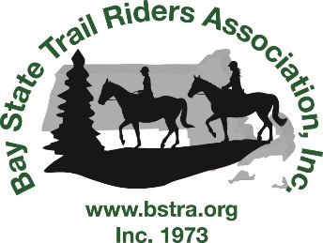

Remit check payable to BSTRA, Inc. with completed form to:
BSTRA, Inc.
c/o Karen Parlin, 92 Old Westboro Road, N. Grafton MA 01536

